R PROGRAMMING LAB MANUAL
Course Code: ITA0408
Course Name: Statistics with R Programming

11. Write an R program to read a .csv file and display contents.
Aim: To write an R program to read a .csv file and display contents.

Procedure:
Step 1: Open RStudio or R console on your computer.
Step 2: Use the read.csv function to load data from a CSV file into R.
Step 3: Store the imported data in a variable for further use.
Step 4: Display a message indicating that the file contents are being printed.
Step 5: Print the data to view all the rows and columns from the CSV file.
Program:
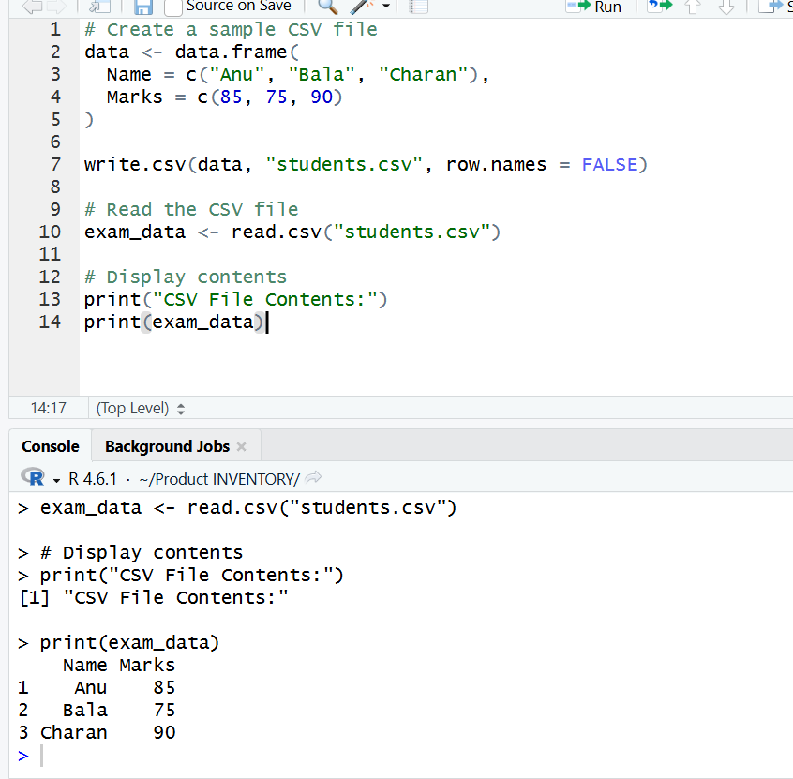
Result:
Hence the output is verified successfully.

12. Perform data reshaping on air quality dataset: melt, cast, compute monthly averages for Ozone, Solar.R, Wind, and Temperature.
Aim: To perform data reshaping on air quality dataset: melt, cast, compute monthly averages for Ozone, Solar, Wind, and Temperature.
Procedure
Step 1: Open RStudio or R console on your computer.
Step 2: Load the built-in dataset airquality available in R.
Step 3: Use the aggregate function to calculate the mean of multiple columns (Ozone, Solar.R, Wind, and Temp) grouped by Month.
Step 4: Include the parameter na.rm = TRUE to ignore any missing (NA) values while calculating averages.
Step 5: Store the calculated monthly average values in a new variable.
Step 6: Print a message to indicate that monthly averages are being displayed.
Step 7: Display the result to view the average Ozone, Solar Radiation, Wind, and Temperature for each month.

R Program:
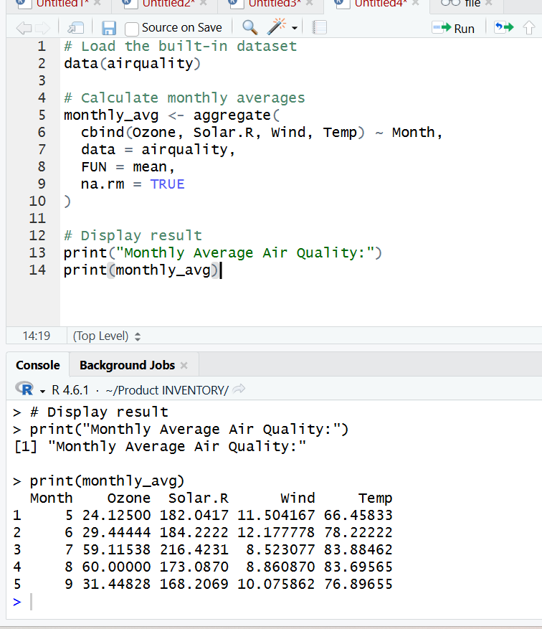

Result:
Hence the output is verified successfully.

13. Combine multiple arrays row-wise.
Aim: To combine multiple arrays row-wise.
Procedure
Step 1: Open RStudio or R console on your system.
Step 2: Remove all existing objects from the workspace using the rm function to start fresh.
Step 3: Create three separate numeric vectors with values.
Step 4: Combine all the vectors row-wise using the rbind function to form a matrix.
Step 5: Print a message indicating that the arrays are combined row-wise.
Step 6: Display the resulting matrix to view the combined data.
R program:
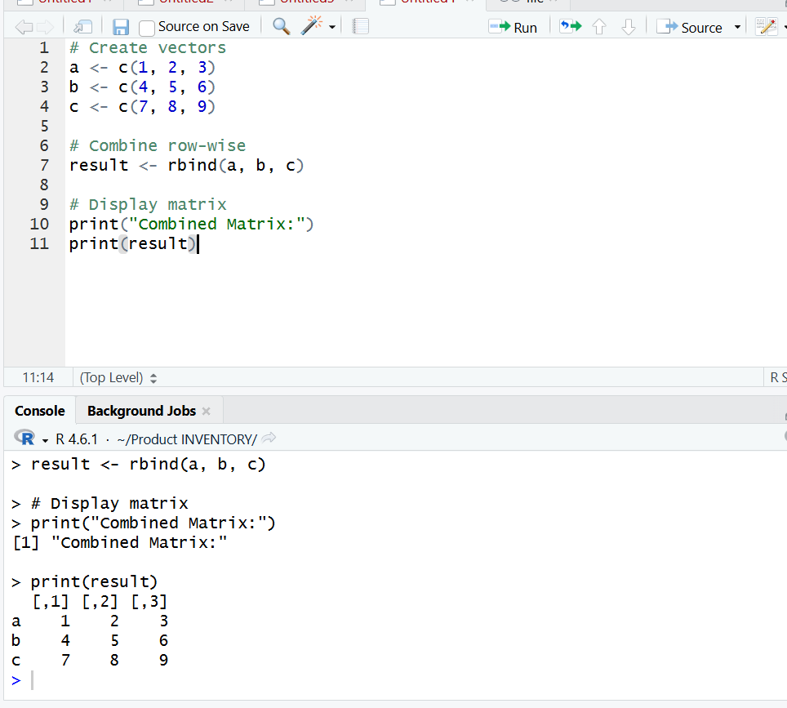
Result:
Hence the output is verified is successfully.

14. Explore and manipulate ChickWeight dataset (sorting, melting, casting by Diet).
Aim: To explore and manipulate ChickWeight dataset (sorting, melting, casting by Diet).
Procedure:
Step 1: Open RStudio or R console on your computer.
Step 2: Load the built-in dataset ChickWeight available in R.
Step 3: Display the first few rows of the dataset using the head function to understand its structure.
Step 4: Sort the dataset in ascending order based on the weight column using the order function.
Step 5: Print the sorted dataset to view the records arranged by weight.
Step 6: Use the aggregate function to calculate the average weight of chicks for each Diet group.
Step 7: Display the result showing the mean weight corresponding to each diet type.

R Program:
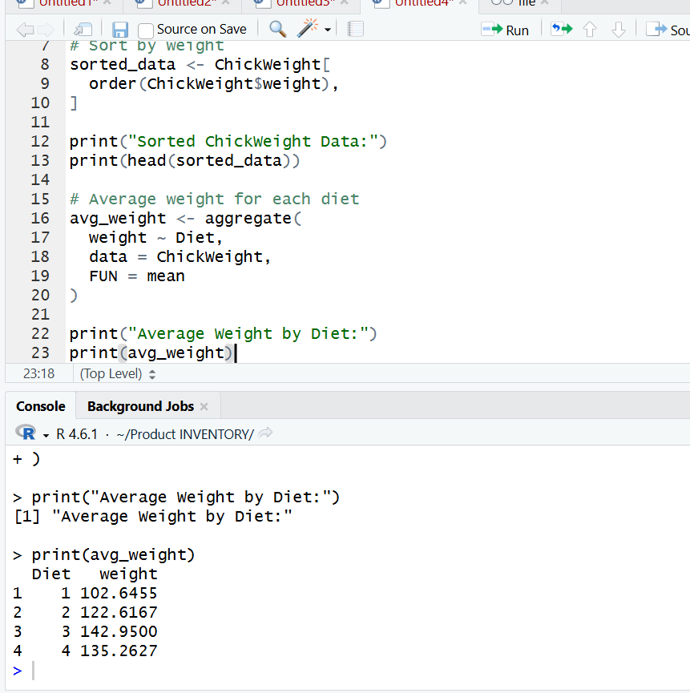
Result:
Hence the output is verified successfully.

15. Perform EDA on iris dataset: dimensions, summary, standard deviation,quantiles, grouping by Species, pivot table, categorical grouping with Sepal.Length categories.

Aim: To perform EDA on iris dataset: dimensions, summary, standard deviation,quantiles, grouping by Species, pivot table, categorical grouping with Sepal.Length categories.

Procedure:
Step 1: Open RStudio or R console on your computer.
Step 2: Load the built-in dataset iris available in R.
Step 3: Use the dim function to find the number of rows and columns in the dataset.
Step 4: Apply the summary function to view basic statistical details such as minimum, maximum, mean, and quartiles for each variable.
Step 5: Use the sapply function with sd to calculate the standard deviation of the numeric columns.
Step 6: Find the quantile values of the Sepal.Length column to understand data distribution.
Step 7: Use the aggregate function to calculate the mean of all numeric variables grouped by Species.
Step 8: Display the results to observe the overall statistical analysis of the dataset.

R Program:
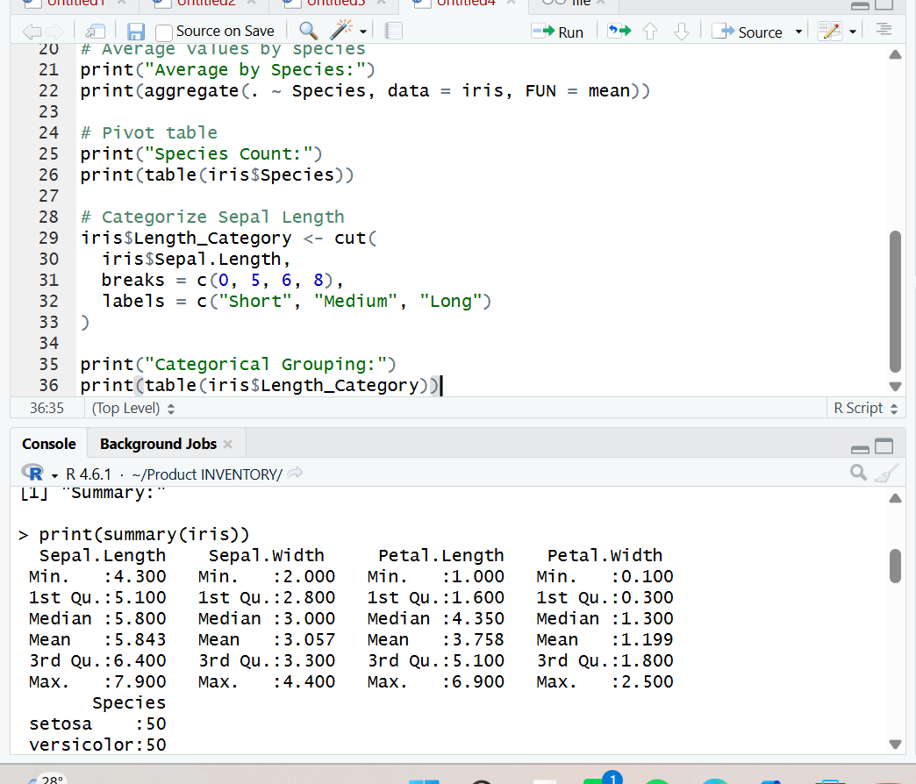

Result:
Hence the output is verified successfully.

16. Explore USArrests dataset: summary statistics, state with largest rape arrests, max & min murder rates, correlation among features, states above median assault arrests and bottom 25% for murder, visualization with histogram, density, scatterplots, bar graphs.
Aim: To explore USArrests dataset: summary statistics, state with largest rape arrests, max & min murder rates, correlation among features, states above median assault arrests and boflom 25% for murder, visualization with histogram, density, scaflerplots, bar graphs.
Procedure:
Step 1: Open RStudio or R console on your computer.
Step 2: Load the built-in dataset iris available in R.
Step 3: Use the dim function to find the number of rows and columns in the dataset.
Step 4: Apply the summary function to view basic statistical details such as minimum, maximum, mean, and quartiles for each variable.
Step 5: Use the sapply function with sd to calculate the standard deviation of the numeric columns.
Step 6: Find the quantile values of the Sepal.Length column to understand data distribution.
Step 7: Use the aggregate function to calculate the mean of all numeric variables grouped by Species.
Step 8: Display the results to observe the overall statistical analysis of the dataset.
R Program:
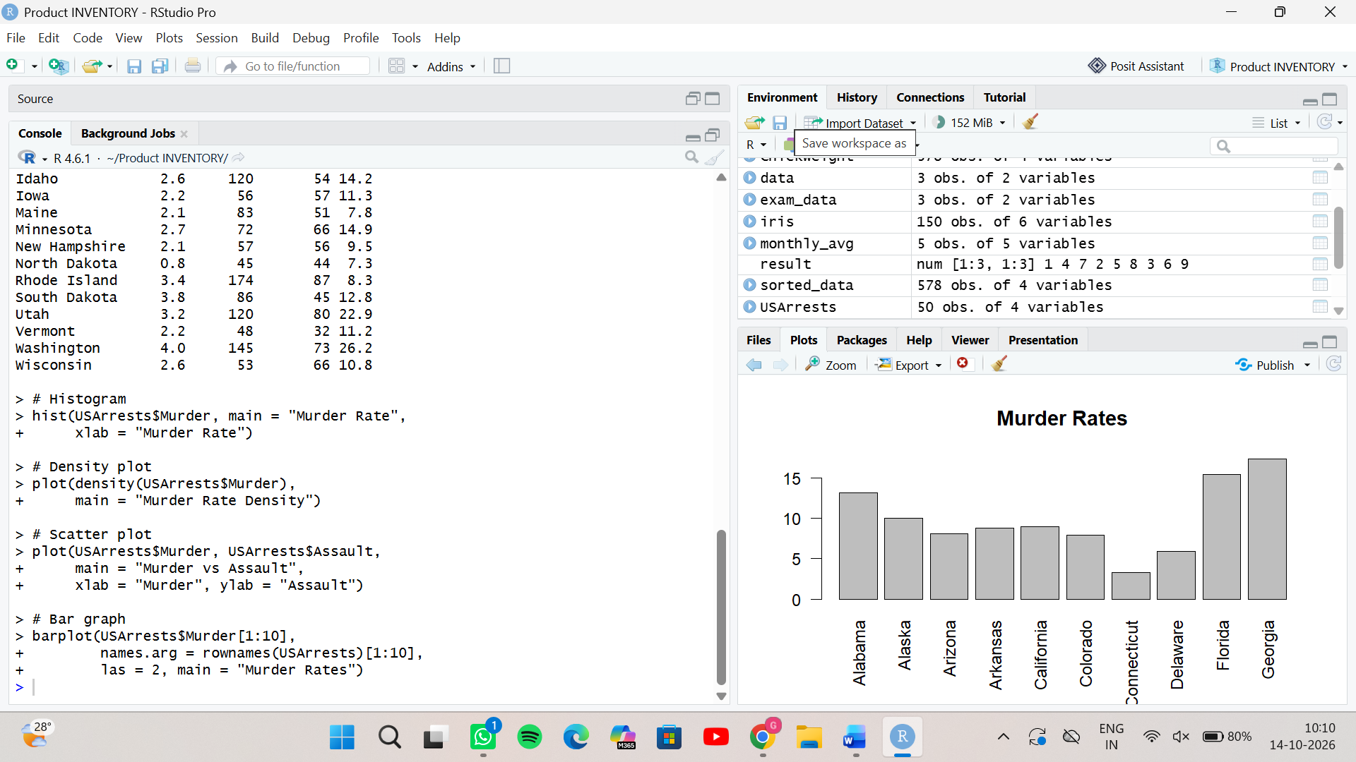

Result :
Hence the output is verified is successfully.

17. Explore Titanic dataset: bar chart of survival vs class, modify plot by gender, histogram of Age.
Aim: To explore Titanic dataset: bar chart of survival vs class, modify plot by gender, histogram of Age.
Procedure:
Step 1: Open RStudio or R console on your computer.
Step 2: Load the built-in dataset Titanic available in R.
Step 3: Convert the Titanic dataset into a data frame format for easier manipulation and plofling.
Step 4: Create a bar plot showing the relationship between Class and Survival using the table function to count frequencies.
Step 5: Add a title to the plot to indicate that it represents Survival vs Class.
Step 6: Create another bar plot to show the relationship between Gender and Survival.
Step 7: Add an appropriate title for the second plot to represent Survival vs Gender.
Step 8: Observe both plots to compare survival paflerns across different classes and genders.
R Program:
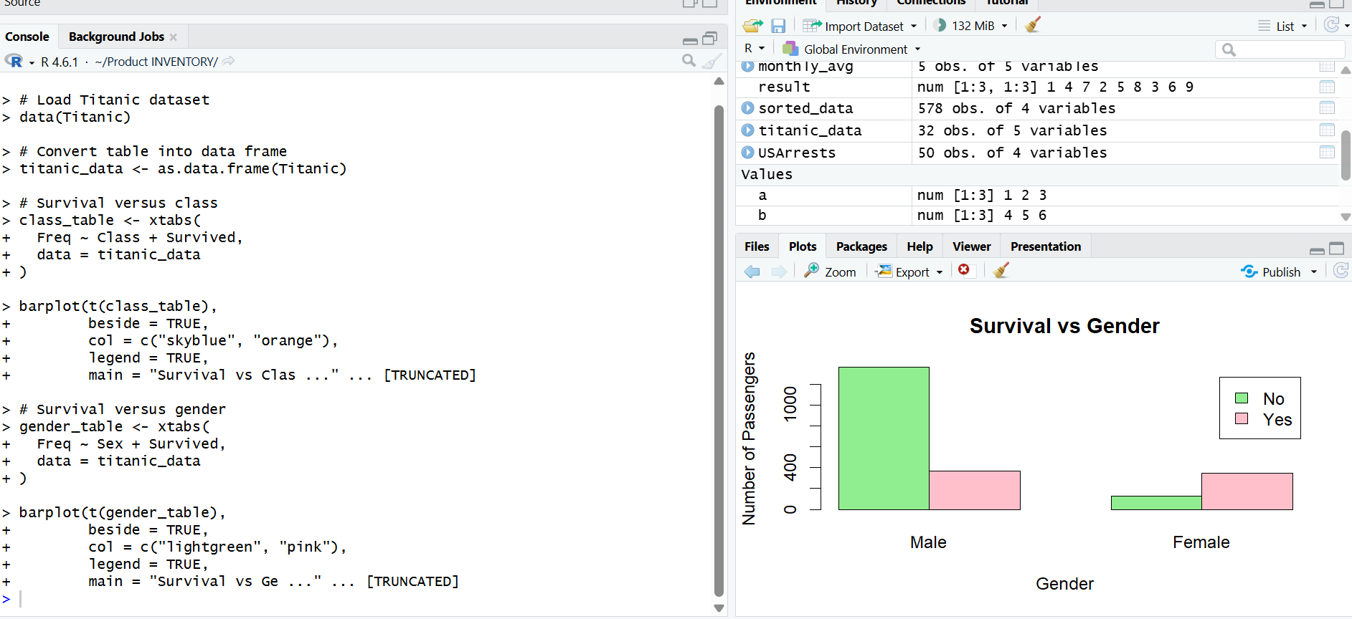

Result:
Hence the output is verified successfully.

18. Create graphs in R: boxplot, histogram, bar plot, line chart, scatter plot.
Aim: To create graphs in R: boxplot, histogram, bar plot, line chart, scafler plot.
Procedure:
Step 1: Open RStudio or R console on your computer.
Step 2: Create two numeric vectors containing values for plofling.
Step 3: Use the par function with mfrow to divide the plofling area into multiple sections for displaying different charts together.
Step 4: Draw a boxplot to show the distribution of the data.
Step 5: Create a histogram to visualize the frequency of values.
Step 6: Generate a bar plot with labeled bars to compare values across categories.
Step 7: Plot a line chart to show the trend of values sequentially.
Step 8: Draw a scafler plot to visualize the relationship between two numeric variables.
Step 9: Observe all the graphs displayed in the multi-plot layout) and predict Sales.
R program:
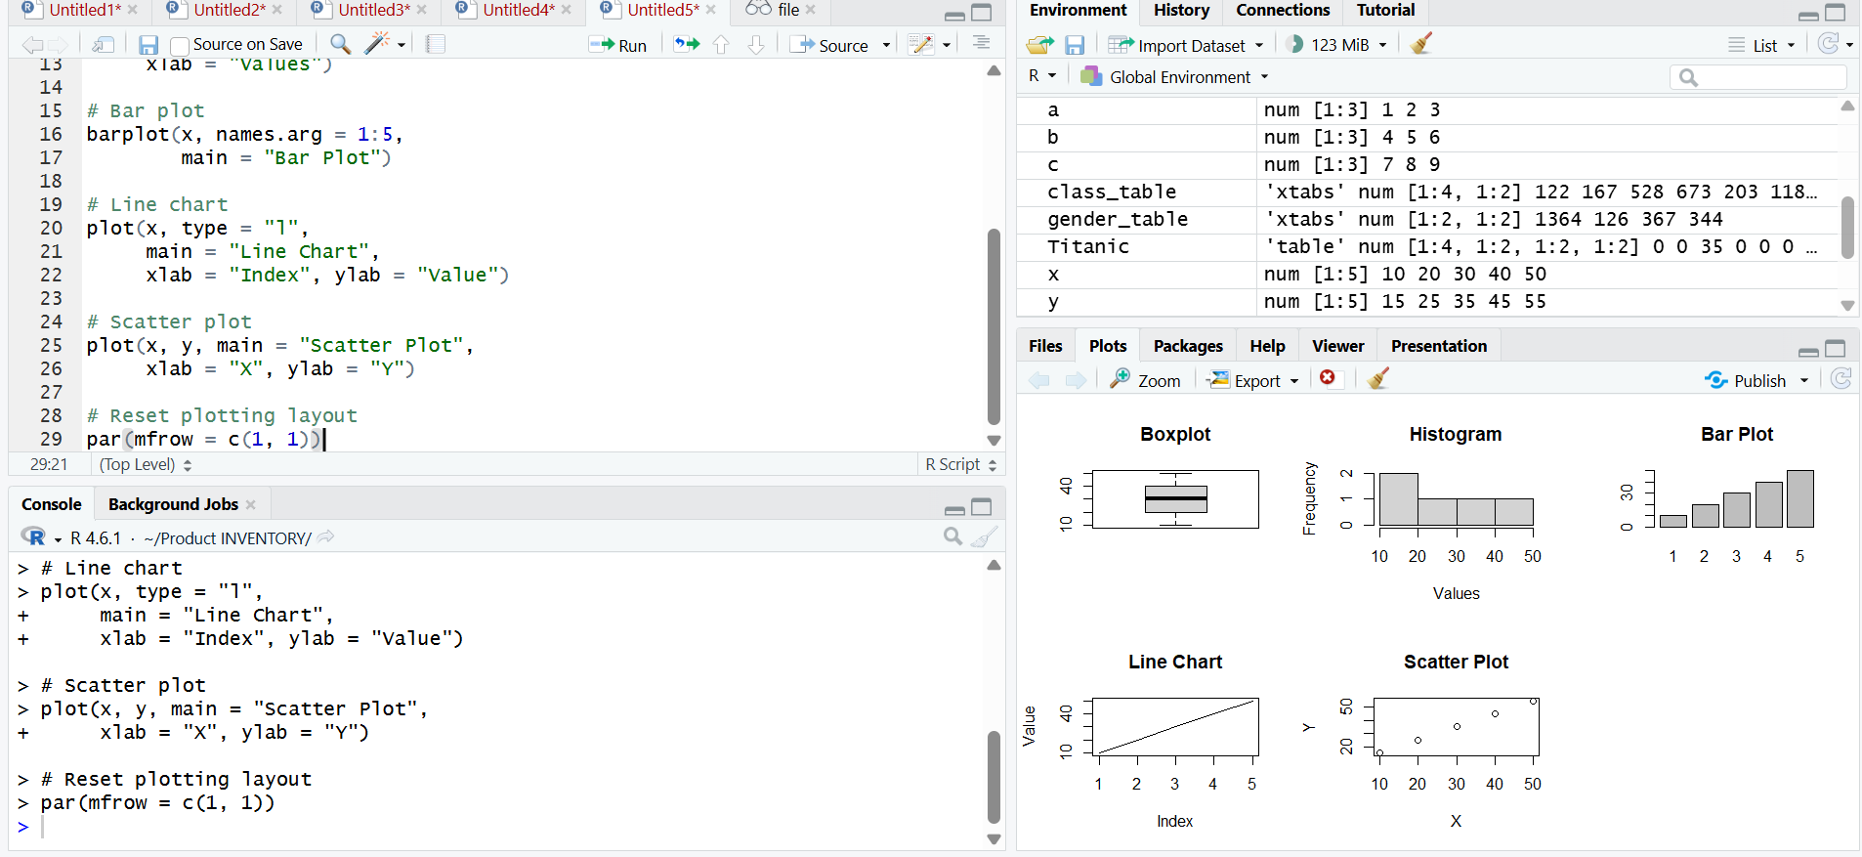

Result:
Hence the output is verified successfully.

19. Build a regression model on advertising dataset (Sales ~ Spend) and predict Sales.
Aim: To build a regression model on advertising dataset (Sales ~ Spend) and predict Sales.
Procedure
Step 1: Open RStudio or R console on your computer.
Step 2: Create two numeric vectors containing values for plofling.
Step 3: Use the par function with mfrow to divide the plofling area into multiple sections for displaying different charts together.
Step 4: Draw a boxplot to show the distribution of the data.
Step 5: Create a histogram to visualize the frequency of values.
Step 6: Generate a bar plot with labeled bars to compare values across categories.
Step 7: Plot a line chart to show the trend of values sequentially.
Step 8: Draw a scafler plot to visualize the relationship between two numeric variables.
Step 9: Observe all the graphs displayed in the multi-plot layout.
R Program:
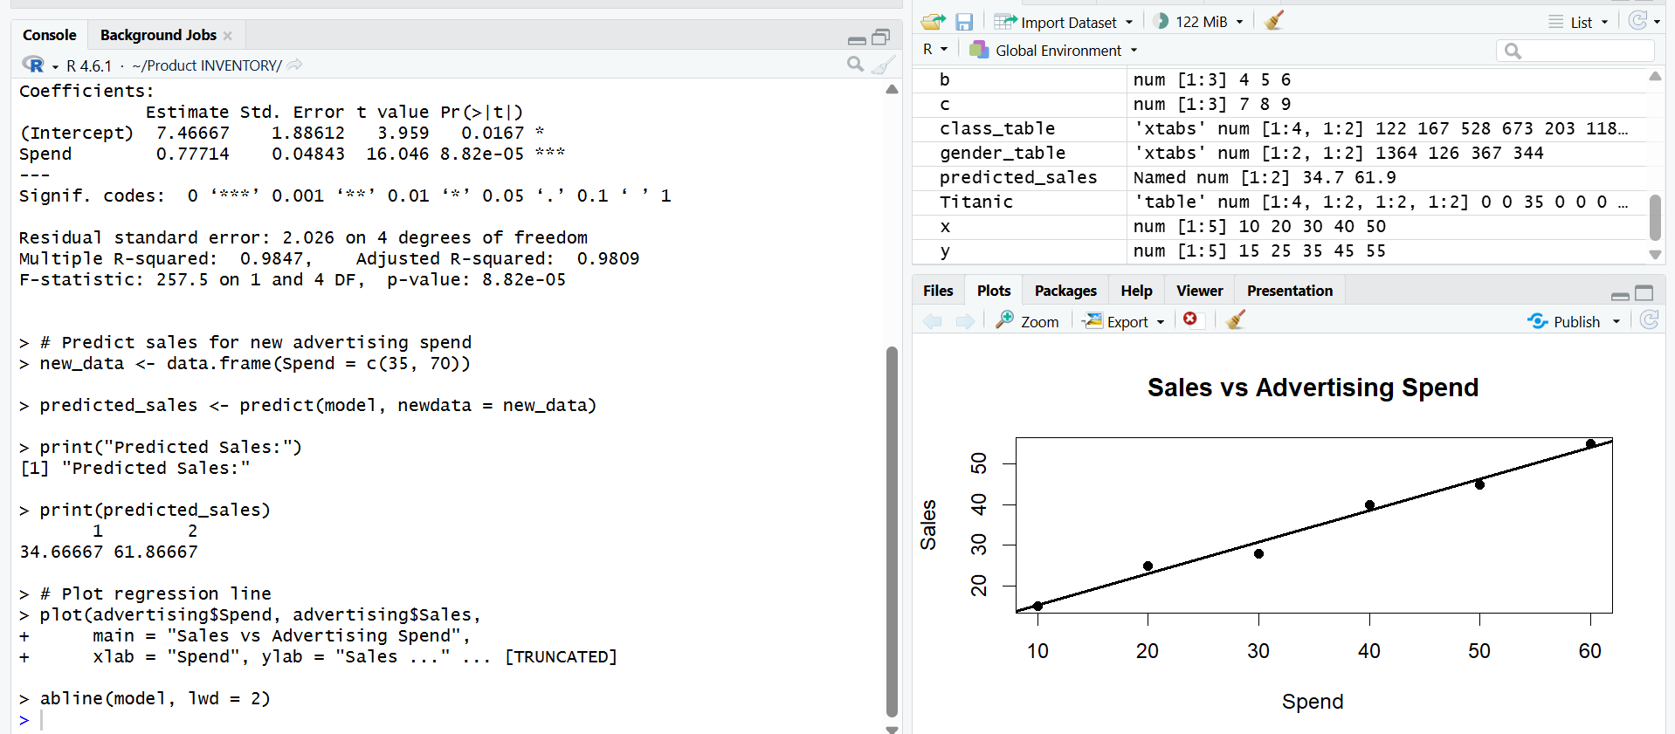

Result:
Hence the output is verified successfully.
20. Create multiple regression model using ChickWeight dataset with “Time” and “Diet” as predictors; predict weight and compute model error.
Aim: To create multiple regression model using ChickWeight dataset with “Time” and “Diet” as predictors; predict weight and compute model error.
Procedure
Step 1: Open RStudio or R console on your computer.
Step 2: Load the built-in dataset ChickWeight available in R.
Step 3: Use the lm function to create a linear regression model where weight is predicted using Time and Diet as independent variables.
Step 4: Use the predict function to generate predicted weight values based on the fifled model.
Step 5: Calculate the mean squared error (MSE) by finding the average of squared differences between the actual and predicted weight values.
Step 6: Display the calculated MSE to evaluate the accuracy of the regression model.

R Program:
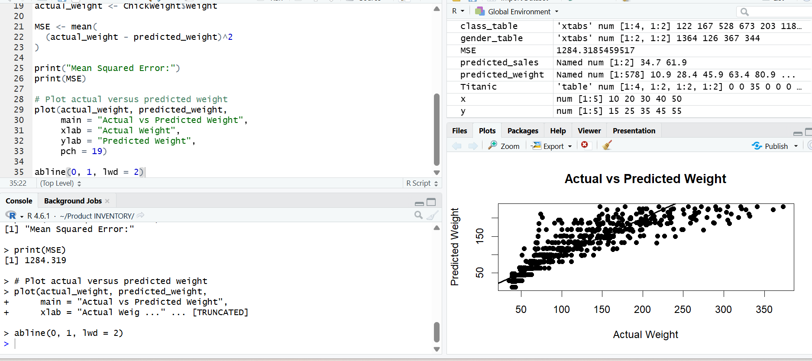

Result:
Hence the output is verified successfully.

